**DABP Final Project Proposal: Optimizing Electricity Arbitrage with Batteries**

Team Members: Colton Lapp, Justin Poser, Ryan Shen

**1. Background:**

Real time temporal arbitrage is seen as a key source of revenue for battery storage systems. With real time temporal arbitrage, charging happens at periods where electricity prices are cheapest, and energy is discharged from batteries to the grid during peak demand periods, where electricity fetches high prices.[1] The New York Independent Service Operator (NYISO) operates the state’s wholesale power market, including power markets, contracts that control transmission, and related products.[2] Every day, the New York ISO issues a 24 hour forecast of energy prices at 11 AM.

Here is an example of our dataset’s headers.

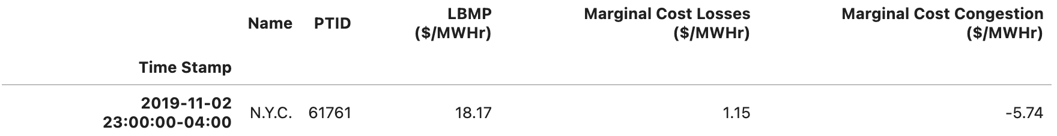

* Name refers to the NYISO region where the market is served. There are eleven zones in total.[3]
* PTID refers to the generator. [Here](http://mis.nyiso.com/public/htm/generator/generator.htm) is a list of all of the NYISO’s generators.
* The LBMP is the locational based market price. This variable will flagged as a buying or selling price when we build our LP model.

For the purposes of our project, we’ll assume (for now) that our energy storage system utilizes lithium ion batteries, which, at the moment, have the highest round-trip efficiency (how much energy is retained when electricity transfers from the grid to the battery and vice versa). The choice of battery will decide our capacity constraints. We’ll also focus on generators in N.Y.C and expand to more zones depending on computational bandwidth.

**2. Question:**

How do we design a project that maximizes profits across a battery storage system over the next month?

**3. Draft of Math Formulation:**

***Objective Function:*** Max P = $\sum_{i=1}^{T}{Pi (LSi - Bi)}$

Pi = the price of electricity at time i.

Si = how many kW to sell at time i

Bi = how many kW to buy at time i.

L = the ratio of how much the batteries can absorb compared to how much electricity is pumped into them.[4]

C = the capacity of a battery.

I = the intake max in kW of one battery.

N = the number of batteries.

***Constraints:***

Amount of kW in battery:

For each time period t and each battery k, 0 ≤ $\sum_{i=1}^{t}{(LBi - Si) }$ ≤ NCk.

For each time period t, LBt ≤ I.

All variables are non-negative.

**Possible Extensions to the Model:**

* We could incorporate battery costs into the model, such that we, as a utility, have the choice to buy or rent a battery through a consumer-owned battery incentive program. We would be comparing the amortized cost of the battery to the rental cost.
  + Using additional battery types which have lower capital costs but lower efficiencies. (Lithium-Ion, the industry gold standard, vs. the Sodium Sulfur)
* Having a discrete amount of electricity (in MW) to attain with our battery storage system

1. Wang, Hao, and Baosen Zhang. “Energy Storage Arbitrage in Real-Time Markets via Reinforcement Learning.” *2018 IEEE Power & Energy Society General Meeting (PESGM)*, 2018, pp. 1–5. *IEEE Xplore*, <https://doi.org/10.1109/PESGM.2018.8586321>.
2. *Electric Power Markets | Federal Energy Regulatory Commission*. https://www.ferc.gov/electric-power-markets. Accessed 12 Nov. 2023.
3. *Nyiso Regions - Google Search*. https://www.google.com/search?client=firefox-b-1-d&q=nyiso+regions#vhid=jxoplkMOIUvFyM&vssid=l. Accessed 12 Nov. 2023.
4. *Utility-Scale Batteries and Pumped Storage Return about 80% of the Electricity They Store*. https://www.eia.gov/todayinenergy/detail.php?id=46756. Accessed 12 Nov. 2023. <https://www.nrel.gov/docs/fy21osti/76097.pdf> (Breakdown of Battery Statistics, LI batteries = 86-88% RTE)